1, Download and install SQL Server Express with **Basic/Default** configuration.  
<https://www.microsoft.com/en-us/sql-server/sql-server-downloads>

2, Then install SSMS.

3, Start the SQL Server Configuration Manager and start the "SQL Server Browser Service".



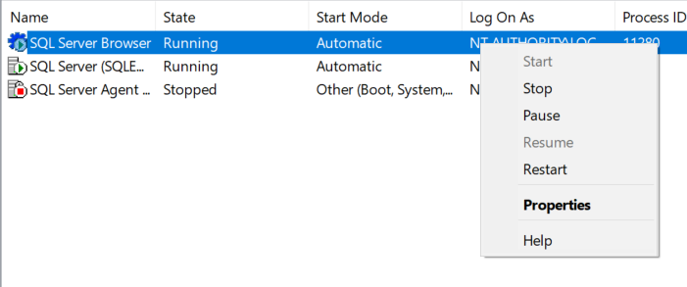

3, In SQL Configuration Manager, set up a TCP/IP port as shown in the pictures below. <https://dzone.com/articles/configuring-spring-boot-for-microsoft-sql-server>



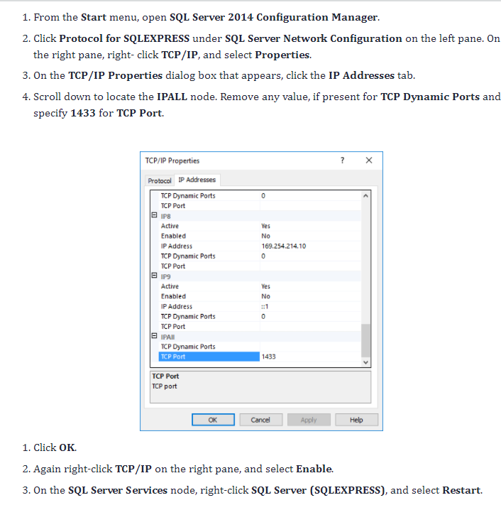

4, Then install the newest version of the Microsoft JDBC Driver, as shown in the picture. <https://stackoverflow.com/questions/6087819/jdbc-sqlserverexception-this-driver-is-not-configured-for-integrated-authentic>

5, Open SSMS, connect to the SQL Express Server, and run /Database (MSSQL)/ CreatePollAppDB.sql to generate the database.

6, Now you can start the Spring Boot project, as it is configured to connect to the database with Windows authentication.